**HOME**

**Photos to change**

1. Women Saving/Meeting to Save

Photo: 20200725_160057.jpg

1. COVID Response

Photo: IMG_20200929_162136.jpg

1. apprenticeship and tool kits distribution (Write capital for all like: Apprenticeship and Tool Kits Distribution)
2. The paragraphs: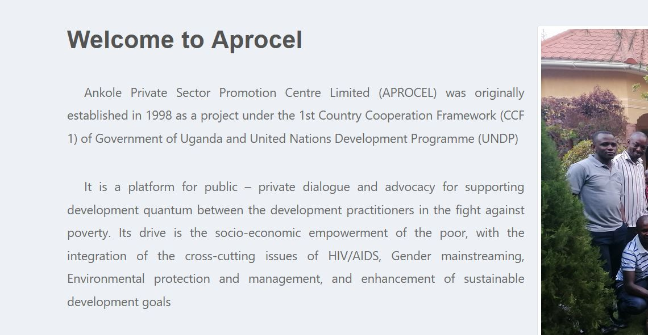

**Welcome to Aprocel**

Ankole Private Sector Promotion Centre Limited (APROCEL) was originally established in 1998 as a project under the 1st Country Cooperation Framework (CCF 1) of Government of Uganda and United Nations Development Programme (UNDP)

It is a platform for public – private dialogue and advocacy for supporting development quantum between the development practitioners in the fight against poverty. Its drive is the socio-economic empowerment of the poor, with the integration of the cross-cutting issues of HIV/AIDS, Gender mainstreaming, Environmental protection and management, and enhancement of sustainable development goals

To me this looks like it is missing a photo to make it look beautiful

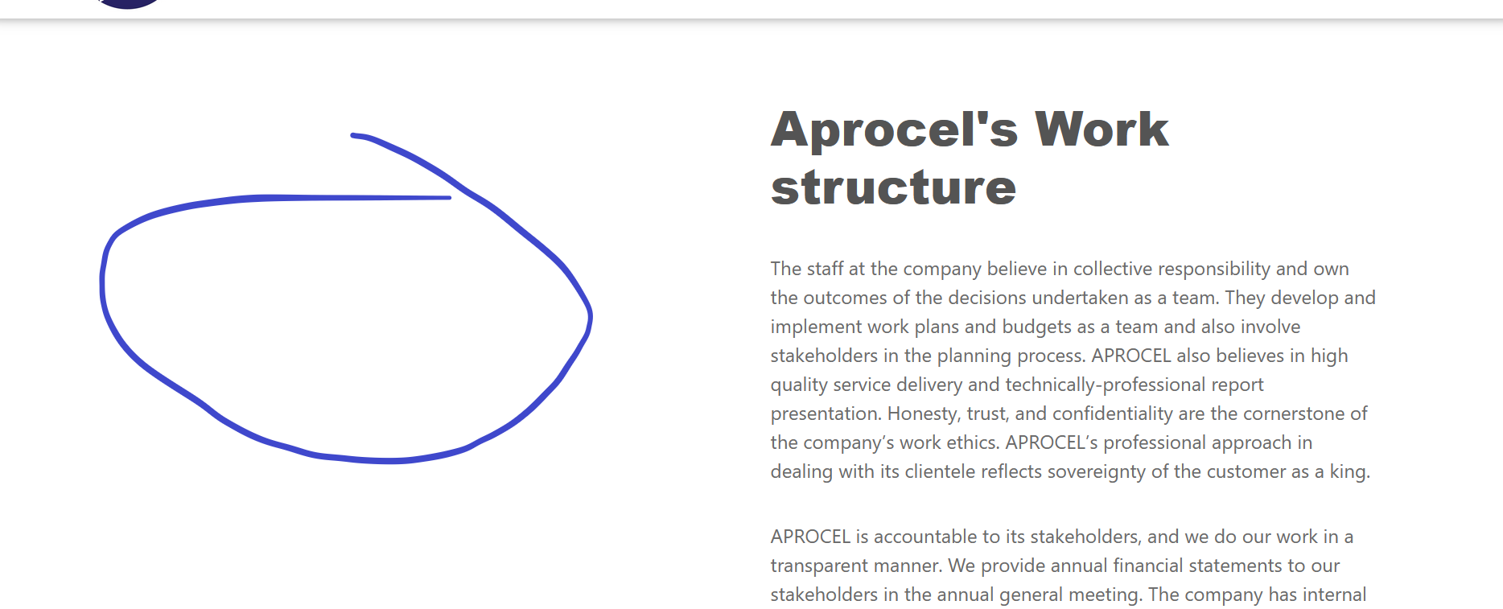

**About Us**

**Our Mission**

Change photo from any of these below;

Photos-IMG_20201007_161730.jpg

Photos – 20200823_165054.jpg

Photos – 20200823_165054.jpg

Photos – Farmers Distributing their products during farmer field day.jpg

Photos – DSC07497.jpg

**Gallery:**

Folders

1. Women saving/meeting to save
2. Cottage industries
3. Apprenticeship and tool kits distribution
4. COVID response
5. Farming
6. Staff
7. All

**Publications:**

1. Add the file titled “End of DSW project report-APROCEL”